Code buster test

1. Timed question [100 Points]: Solve this Aristocrat which is a quote by Hellen Keller. When you have solved it, raise your hand so that the time can be recorded and the solution checked.

SURM BQLWVSZ IMUI G NLVHSE WSRUZS U QCVS PMGRM NSQHSE UYISQPUQEN IL NLVHS LIMSQ BQLWVSZN.

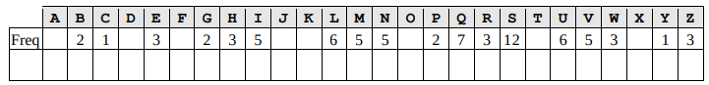

2. [80 Points] Solve this Aristocrat which is a quote by Mark Train which is encoded using a K1 key.

RY RM JGYYGF YK LGGW DKZF UKZYQ NTKMGI HVI TGY WGKWTG YQRVL DKZ HFG H OKKT YQHV YK KWGV RY HVI FGUKAG HTT IKZJY.

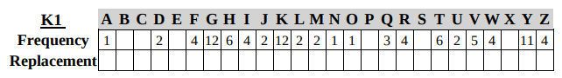

3. [60 Points] Solve this Aristocrat which is a quote by William S. Burroughs which is encoded using a K1 key.

VNG JOQ DM GHWLJVODC OU VNG BCDEFGHIG,

CDV DM MJLVU, KWV DM XJFWGU

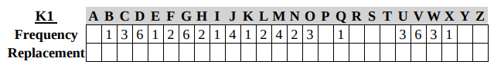

4. [75 Points] The following encodes a phrase using a Baconian alphabet. What does it say?

Answer: ________________________________________________________

séé ýou rácińg see ýou rácińg sée yóú raćinģ see you racińģ see yoú racing sée yoú racínģ śee yóú ráćinģ see you rácíng śée ýoú ŕacinģ śeé you racing see ýou rácinģ see ýou ŕacíng sée yoú rácíńg see yoú ŕacínģ śeé you ŕacíńģ séé yóú racing sée ýou racing see yóu raćinģ see ýoú ŕaćińģ see yóu racing seé yóú raćing śee ýou raćinģ see ýóú raćing śée ýóu rácinģ śée yóu rácing

5. [300 Points] Solve this Patristocrat which is a quote by Albert Camus which is encoded using a K1 key and starts with the word IN.

CGWXU SUHWX QATCG WUYCA CGVRR NRUVY GUSWX VWWXU

YUTVJ CGFUV GCGLC GPCZR UJKFF UY

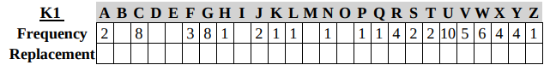

6. [250 Points] Solve this Spanish Xenocrypt which is a quote by Adam Smith

